For sportsmedicine and rehabilitation

Force measurement on the cranks
Lode proudly introduces the latest technique in the field of Pedal Force Measurement (PFM). Together with the reliability of the renowned bicycle ergometer Excalibur Sport this results in a unique combination for your sportmedical stress testing.

As you know you can show your client the performance in both the aerobic and anaerobic field. The ergometer (1300 watt) is optimal adjustable so your client has optimal seat comfort. With the renewed PFM option you are able to measure how the forces are divided over the cranks without any extra effort for the test subject.

With the measured values you can advise your client better about a.o.:
- Injuries
- Efficiency of the bicycle movement
- Body attitude at the bicycle
- Left-right comparison
- Evaluation rehabilitation process
- Adjustments of the racing bike

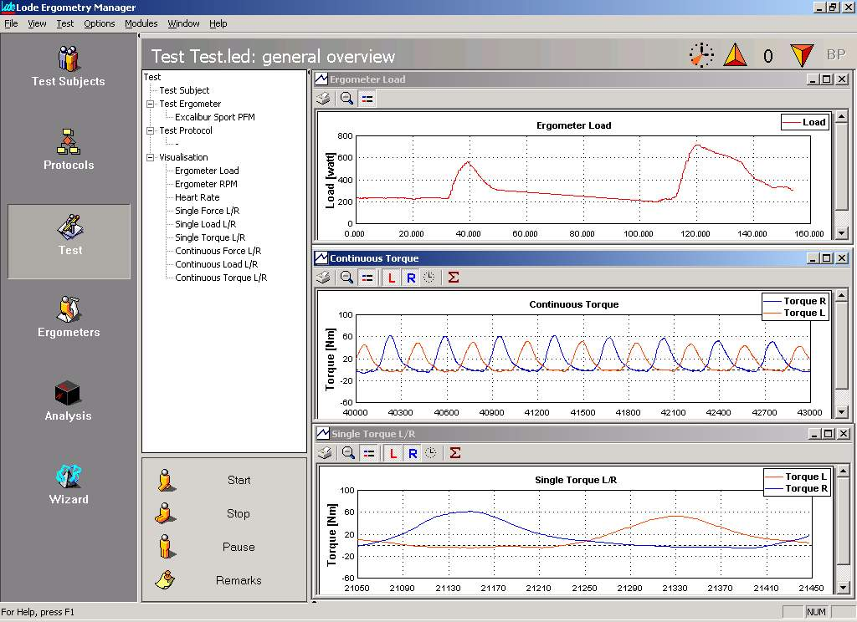

With only one test you get a clear insight into the physiologic and biomechanic possibilities of your client, which enables you to give a better advise and support.

Easy processing and analysis of data
Next to the renewed technique for pedal force measurement within the ergometer, the processing and analysis of the acquired data is much easier with the new Lode software for Pedal Force Measurement.
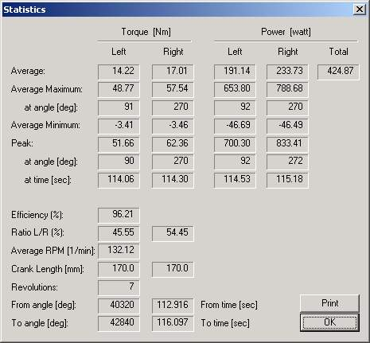
- Protocols for pedal force measurement can be programmed based on time intervals (with a maximum of 60 minutes), enabling a continuous registration of the pedal force. Furthermore it is possible to choose protocols based on intervals; you can measure the pedal force during some seconds.
- During the test, you will receive on-line clear graphic representations of the forces performed on the left and/or right crank.
- The workload can be changed during the test and you can save comments with the test data.
- The analysis offers the possibility to define “area’s of interest” (AOI) and to edit these separately.
- Numeric data like peak values, averages, absolute maximum, angle, total efficiency, rpm and left/right ratio are registered and saved. Export to statistical programs is possible with the optional exportmodule.

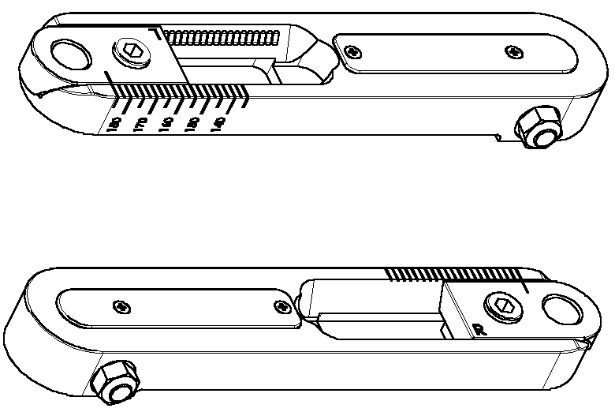
Cranks and pedals
The adjustable cranks (optional available) are excellently suitable for use with pedal force measurement. These cranks are stepless adjustable and give an indication click at each step of 2.5 mm within a range of 135-185 mm. The distance between the left and the right pedal, measured from the outside of both cranks is 142 mm. In the calibration application the correct cranksize can be indicated. In order to enable your client to imitate the feeling of his/her own racing bike it is possible to use the renowned click pedal systems on the adjustable cranks.

Lode software
The Lode software for pedal force measurement is operating under the shell software the “Lode Ergometry Manager” (LEM) and is suitable for Windows (‘98/2000). The PFM module is linked to the central database for patient data. When more modules within the Lode Ergometry Manager are active, the modules are connected with each other automatically.

